Supplemental information
Characteristics of rice panicle photosynthesis and its correlation with grain yield related traits

Tian-Gen Chang¹, Qing-Feng Song¹, Hong-Long Zhao^{1,2}, Shuoqi Chang³, Changpeng Xin⁴, Xin-Guang Zhu^{1,2*}

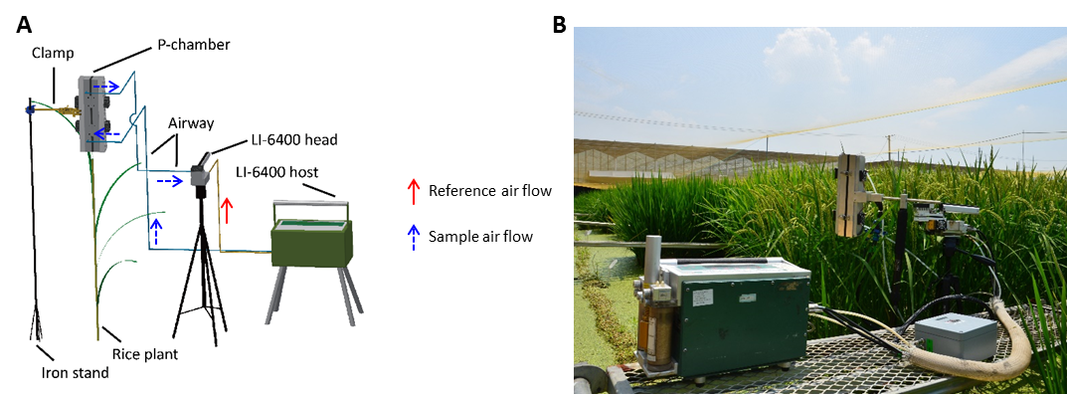
Supplemental Figure S1. Using the P-chamber to measure panicle gas exchange. A, An illustration of how the P-chamber works together with a standard gas analyzer (Li-6400, Li-Cor Inc., Lincoln, Nebraska, USA) to measure the photosynthetic and respiratory rate of a rice panicle. B, The setting of a P-chamber in a paddy field.

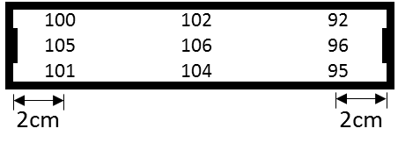
Supplemental Figure S2. Relative light intensity at different positions of the P-Chamber.

Supplemental Table S1. Area of flag leaves and estimated ratio of light saturated gross photosynthetic rates between a panicle and a flag leaf. Abbreviations: FLA, flag leaf area (cm²); EFL A_{gross}, estimated light saturated gross photosynthetic rate of a whole flag leaf by assuming a constant light saturated photosynthetic rate of 25 μmol m⁻² s⁻¹ (nmol s⁻¹); P/FL A_{gross}, estimated ratio of light saturated gross photosynthetic rates between a panicle and a flag leaf at around 5 days after heading. The light saturated gross photosynthetic rate of a panicle was taken from Table 1. Data measured in 2016 (n=5). Different letters beside numbers showing statistical significance (p-value < 0.05) using one-way analysis of variance (ANOVA).
 | YLY900 | CY1000 | SY63 | R9311 | XS134 | YY538 | YY17
FLA | 73.8±11b | 88.1±11.3a | 61.9±10.9cd | 56.2±12.1de | 32.6±4.4f | 48.7±8e | 72.3±8.4bc
EFL A_{gross} | 184.5 | 220.25 | 154.75 | 140.5 | 81.5 | 121.75 | 180.75
P/FL A_{gross} | 0.257 | 0.201 | 0.321 | 0.381 | 0.21 | 0.212 | 0.199

